**Summary Report**

First, follow the step on the Species Lab Slide and make 9 code file for the Page Rank,

Separate them in 9 different java file.

Run the file in the Cygwin and get the first output.

In my code, I have already set the input file and output file ‘s directions and every driver or runner can read other’s output file automatically :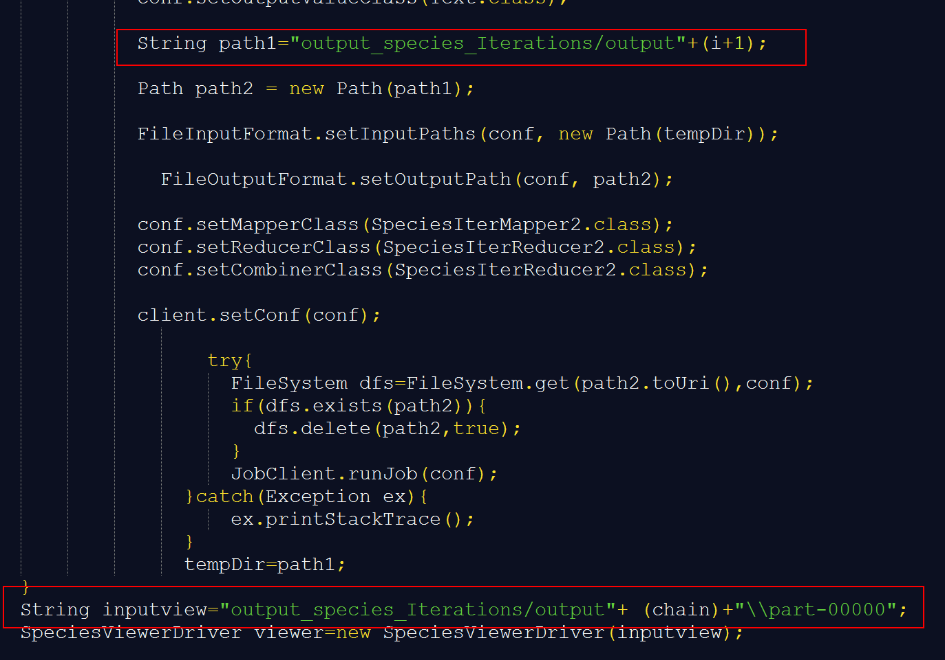

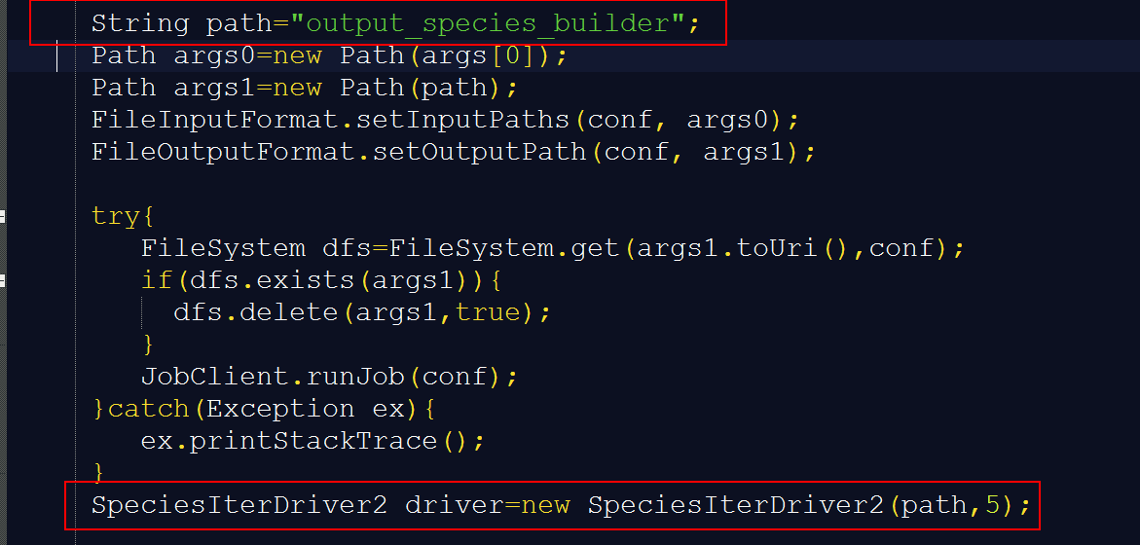

and my iterations run for 5 times:

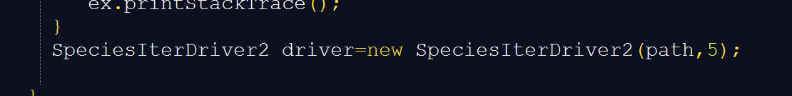

5 is the parameter for the function SpeciesIterDriver class because I have made a for loop for the iterations:

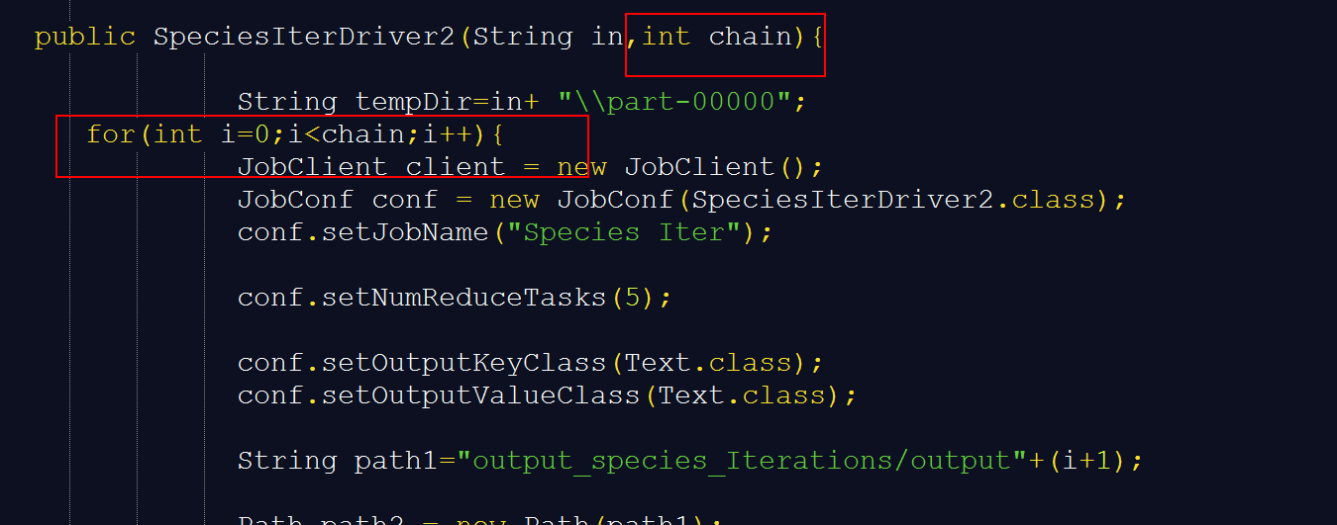

After if run the iteration 5 times, it converges.

Than we got the output files for every steps:



Iterations:

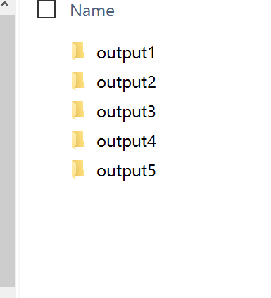

Builder’s Output:

